|  |  |
| --- | --- |
| **Name:-** Aryan Dilipbhai Langhanoja | **Roll Number:- 92200133030** |
| **Subject Name and Code:-** Basics of Electronics Engineering (01EC101) | **Date of Experiment:-** 26-12-2022 |

|  |  |
| --- | --- |
| What Is Transistors:- |  |

* A transistor is a type of a [semiconductor](https://byjus.com/jee/semiconductors/) device that can be used to both conduct and insulate electric current or voltage. A transistor basically acts as a switch and an amplifier. In simple words, we can say that a transistor is a miniature device that is used to control or regulate the flow of electronic signals.
* Transistors are one of the key components in most of the electronic devices that are present today. Developed in the year 1947 by three American physicists John Bardeen, Walter Brattain and William Shockley, the transistor is considered as one of the most important inventions in the history of science.

|  |  |
| --- | --- |
| Parts Of Transistors:- |  |

* A typical transistor is composed of three layers of semiconductor materials or more specifically terminals which helps to make a connection to an external circuit and carry the current. A voltage or current that is applied to any one pair of the terminals of a transistor controls the current through the other pair of terminals. There are three terminals for a transistor. They are:-
* **Base: -** This is used to activate the transistor.
* **Collector: -** It is the positive lead of the transistor.
* **Emitter**: - It is the negative lead of the transistor.

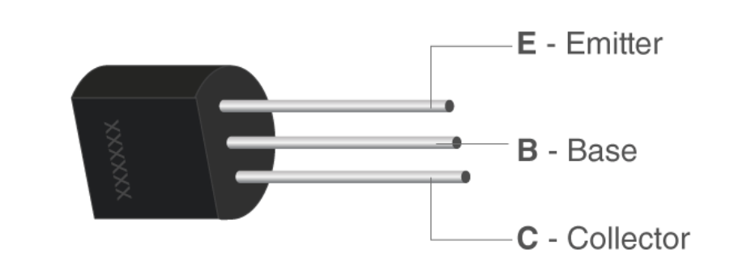

* **Thickness and Doping of Emitter, Base and Collector:-**

|  |  |  |
| --- | --- | --- |
|  | Thickness | Doping |
| Emitter | Wide | Heavily Doped |
| Collector | More Wide than Emitter | Moderately Doped |
| Base | Very Thin | Lightly Doped |

|  |  |
| --- | --- |
| Types Of Transistors:- |  |

* **N-P-N Transistors & Symbol In Circuit:-**

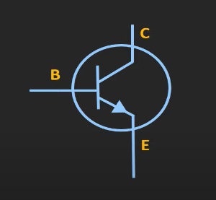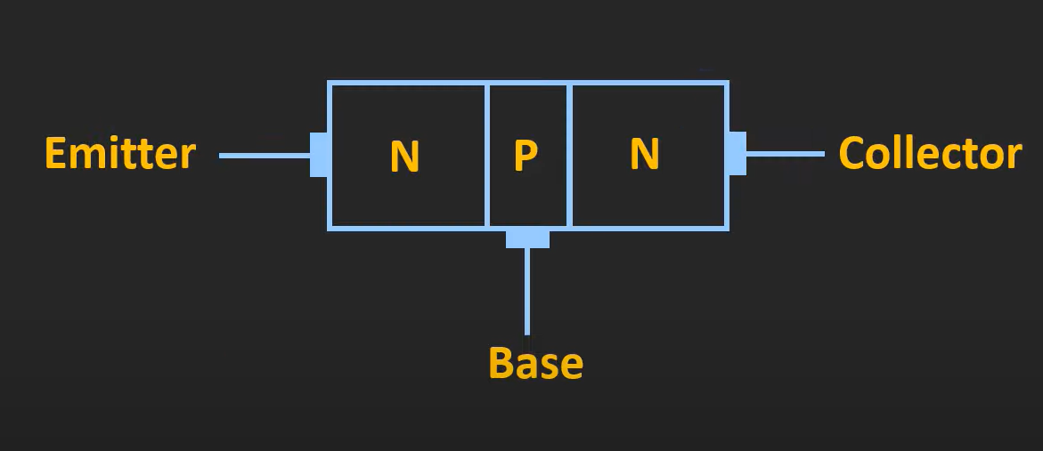

**N-P-N Transistors Symbol**

* In this transistor, we will find one p-type material that is present between two n-type materials. N-P-N transistor is basically used to amplify weak signals to strong signals. In NPN transistor, the electrons move from the emitter to collector region resulting in the formation of current in the transistor. This transistor is widely used in the circuit.
* **P-N-P Transistors Symbol In Circuit:-**
* It is a type of BJT where one n-type material is introduced or placed between two p-type materials. In such a configuration, the device will control the flow of current. PNP transistor consists of 2 crystal diodes which are connected in series. The right side and left side of the diodes are known as the collector-base diode and emitter-base diode, respectively.

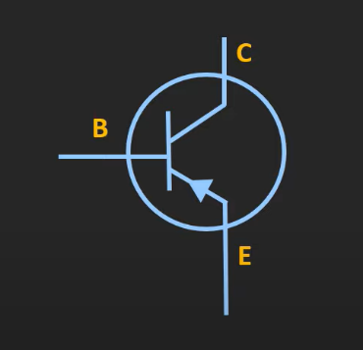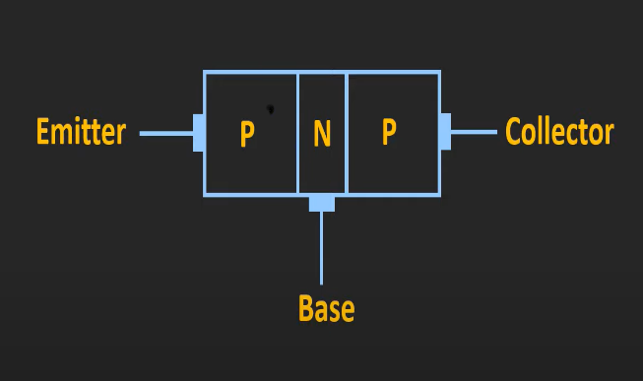

|  |  |
| --- | --- |
| Transistors Configuration |  |

* There Are **Three** Types Of Transistors Configuration-

1. Common Emitter Transistor **(CE)**

* In Common Emitter (CE) configuration the emitter terminal is common between the input and the output terminals.

1. Common Base Transistor **(CB)**

* In Common Base (CB) configuration the base terminal of the transistor is common between input and output terminals.

1. Common Collector Transistor **(CC)**

* In Common Collector (CC) configuration the collector terminals are common between the input and output terminals.

|  |
| --- |
| Region Of Operation:- |

* There Are **Four** Different types of Operating Regions for transistors:-

1. Active Region.
2. Cut-Off Region.
3. Saturation Region.
4. Reverse Active Region.

Let, Collector Voltage = Vc , Emitter Voltage=Ve , Base Voltage=Vb

|  |  |
| --- | --- |
| Region Of Operation | Voltage Comparison |
| Cut-Off Region | Ve>Vb & Vc>Vb |
| Reverse Active Region | Ve>Vb >Vc |
| Saturation region | Vb>Ve & Vb>Vc |
| Active Region | Vc>Vb>Ve |

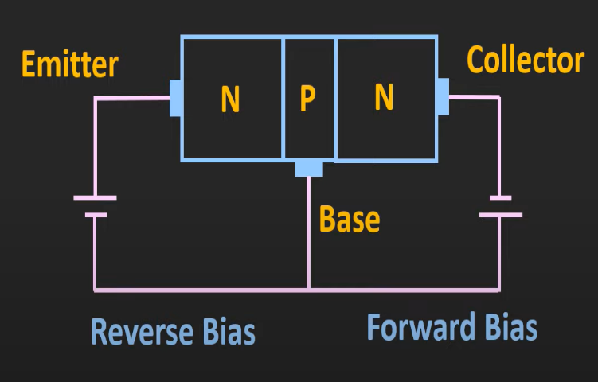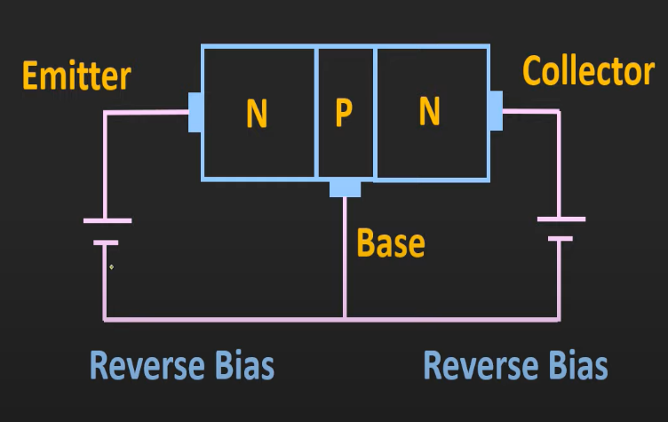

Cut-Off Region Reverse-Active Region

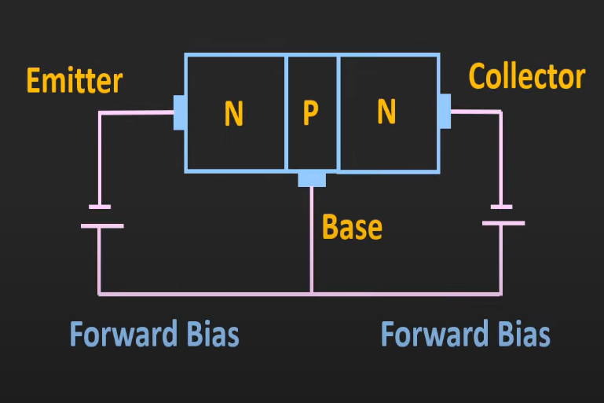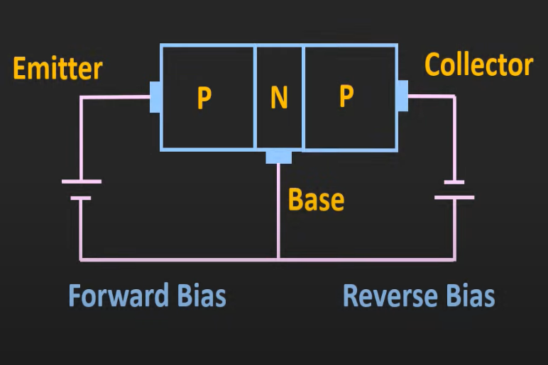

Saturation regionActive Region

|  |
| --- |
| Application Of Transistors |

1. As A Switch
2. As An Amplifier

|  |
| --- |
| Biasing Method of Transistors |

* There Are **Four** Types Of Transistor Biasing**.**

1. Fix Biased
2. Fix Biased With Emitter Resistor
3. Collector to Base Bias
4. Voltage Divider Bias
5. Emitter Bias

* **Fix-Bias Configuration**

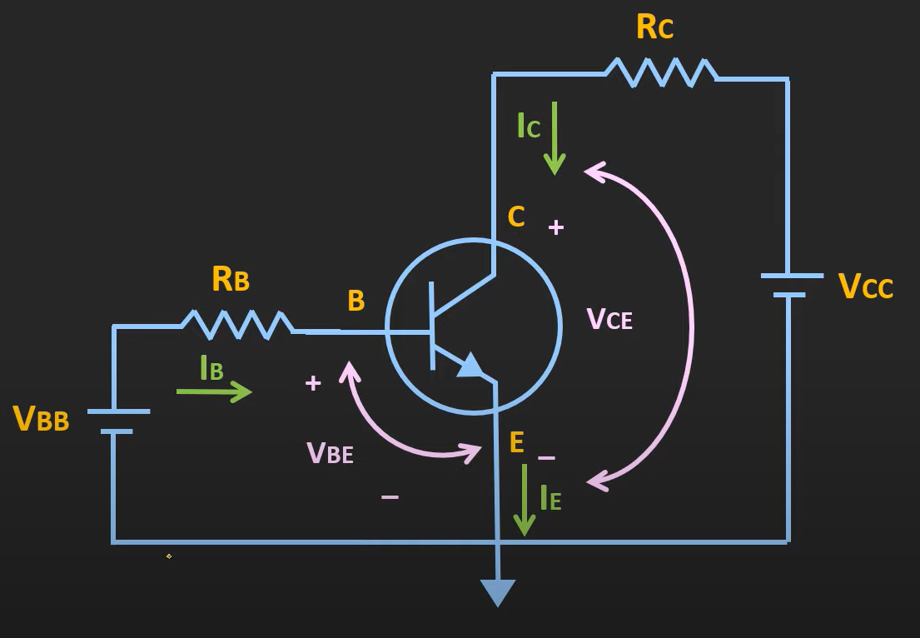

* In This Figure, Shown that Voltage Given at Base-Emitter Junction is VBB and Voltage Given at Emitter-Base Junction is VEE. We are using active Region of operation.
* When we applied Voltage at Emitter, Emitter emits lot of free electron, because it is heavily doped. That Electron Enters in Base. Where some holes are present. And electron combines with them.
* Now electron has two choices, go to VBB or to go VCC. Because VCC>>VBB. Some electrons are attracted by VBB and rest all electron is attracted by the VCC. And it is shown that the current is IC due to that. And the current IB is the current produces by the electron attracted by the VBB.

Now, applying KCL, we can say that IE **=** IB + IC ……… (1)

* As already mentioned that very few electron attracted by VBB

∴ IC ≈ IE

∴ IC = α IE ……… (2).

* Now, From eq (1).

**∴** IE **=** IB + α IE

∴ IB **=** IE - α IE

∴IB **=** IE - α IE

∴IB **= (**1- α) IE

From eq (1) IE = IC / α .

∴IB **= (**1- α) IC / α .

∴ IB **= (**1- α/ α) IC .

∴ IC = (α/1- α)IB .

∴ IC = (α/1- α)IB

|  |
| --- |
| ∴ **Ic = βIB** |

Where β is called the current gain.

* Now, if we took Emitter-Base Loop and apply KVL in it,

∴ VBB- IBRB – VBE = 0.

|  |
| --- |
| **∴ IB = VBB – VBE**  **RB** |

And Now, if we took Collector-Base Loop and apply KVL in it,

∴ VCC -ICRC – VCE = 0.

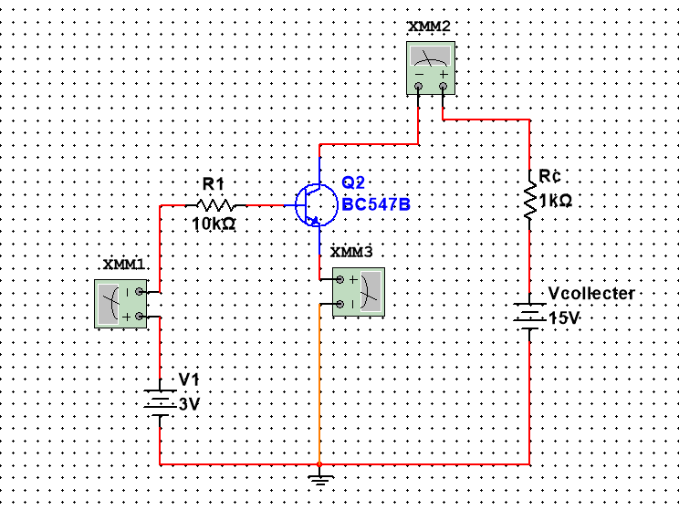

|  |
| --- |
| ∴**VCE = VCC -ICRC** |

* **Multisim Circuit**:-

* Observation Table:-

|  |  |  |  |
| --- | --- | --- | --- |
| VCC | RC | IC | VCE |
| 12 V | 1 K Ω | 11.902 mA | 0.098 V |
| 12 V | 1.01 KΩ | 11.784 mA | 0.09816 V |
| 12 V | 1.02 KΩ | 11.669 mA | 0.09762 V |
| 12 V | 1.03 KΩ | 11.556 mA | 0.09732 V |
| 12 V | 1.04 KΩ | 11.446 mA | 0.09616 V |

* **Fix Bias With Emitter Resistor**

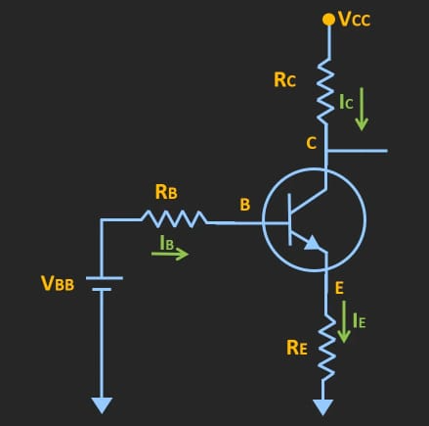

* In this condition, the Emitter Resistor RE will act as a feedback resistor. In any situation, temperature changes, then β changes. Let suppose the temperature increases, then β increases, and for the fix current IB, Collector Current IC will increases. Then the voltage drop across emitter Resistor will also increase. and base voltage VBE will also increase. And because of VBE increased VB is also increased and IB will decrease. And Q-point will be stable.
* Now, if we took Emitter-Base Loop and apply KVL in it,

∴ VBB- IBRB – VBE – IERE = 0.

∴ VBB- IBRB – VBE – IERE = 0.

∴ VBB- IBRB – VBE – (IB + IC)RE = 0.

∴ VBB- IBRB – VBE – (IB +βIB )RE = 0.

∴ VBB- IBRB – VBE – (1 +β )IBRE = 0.

|  |
| --- |
| **∴ IB = VBB – VBE**  **RB + (β+1)RE** |

And Now, if we took Collector-Base Loop and apply KVL in it,

∴ VCC -ICRC – VCE - IERE = 0.

|  |
| --- |
| ∴**VCE = VCC –IC(RC + RE)** |

* **Multisim Circuit:-**

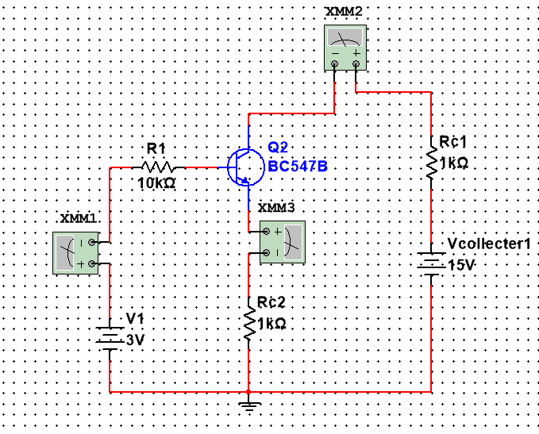

* Observation Table:-

|  |  |  |  |  |
| --- | --- | --- | --- | --- |
| VCC | RC | IC | RE | VCE |
| 12 V | 1 KΩ | 2.287 mA | 1 KΩ | 9.713 V |
| 12 V | 1.01 KΩ | 2.287 mA | 1 KΩ | 9.69013 V |
| 12 V | 1.02 KΩ | 2.287 mA | 1 KΩ | 9.66726 V |
| 12 V | 1.03 KΩ | 2.287 mA | 1 KΩ | 9.64439 V |
| 12 V | 1.04 KΩ | 2.287 mA | 1 KΩ | 9.62152 V |

IC 🡪 VCE GRAPH Q-POINT STABILITY

* Fix Base With Emitter Resistor
* Fix-Base